10th March 2026

Dear Applicant

Head of Business Studies – 0.6-0.8 FTE

Thank you for the interest you have shown in our advertised post of Head of Business Studies from September 2026.

We are seeking an enthusiastic Head of Business with the ability to teach throughout the key-stages to lead this successful and dynamic department.
The successful candidate will be someone who can demonstrate the ability to:

- teach effectively across the age and ability range;
- improve teaching and learning across the subject;
- coordinate an exciting extra-curricular programme
- develop our reputation for excellence
- create an exciting and challenging learning environment for all students;
- have high expectations of students;
- contribute to clubs and the extra-curricular provision.

Oldfield School is committed to safeguarding and protecting the welfare of children and young people and expects all staff and volunteers to share this commitment. Successful candidates will be required to complete an enhanced DBS disclosure.

The closing date is midnight on 22nd March 2026; interviews will be held the next week.

Unfortunately, due to the high response rate that we receive for posts such as these, we are unable to offer feedback on individual applications which are not shortlisted for interview.

We very much hope you will pursue your interest in this application.

Yours sincerely
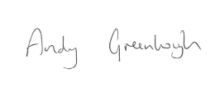
Andy Greenhough
Headteacher

