17th March 2026

Dear Applicant

Head of Media and Film Studies – 0.6-0.8 FTE

Thank you for the interest you have shown in our advertised post of Head of Media and Film Studies from September 2026.

We are seeking an enthusiastic department head with the ability to teach throughout the key-stages to lead this innovative and popular department.
The successful candidate will be someone who can demonstrate the ability to:

- teach effectively across the age and ability range;
- improve teaching and learning across the subject;
- developing and evaluating the curriculum;
- monitoring the quality of the teaching and learning within the subjects;
- promotion of media/film through extra-curricular activities;
- coordination of the exam coursework.

Oldfield School is committed to safeguarding and protecting the welfare of children and young people and expects all staff and volunteers to share this commitment. Successful candidates will be required to complete an enhanced DBS disclosure.

The closing date is midnight on 29th March 2026; interviews will be held the next week.

Unfortunately, due to the high response rate that we receive for posts such as these, we are unable to offer feedback on individual applications which are not shortlisted for interview.

We very much hope you will pursue your interest in this application.

Yours sincerely
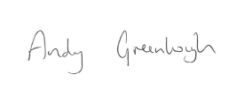
Andy Greenhough
Headteacher

