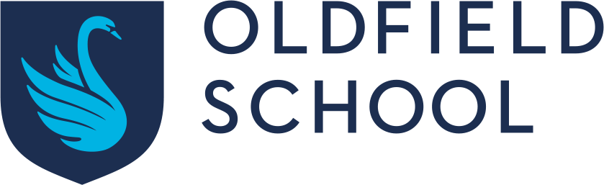

Uniform Grant Form

If your child is eligible for free school meals, we give you a credit note for our school uniform supplier, Price and Buckland, allowing you to purchase up to £80 of uniform over your child’s life at the school. To apply for that credit note, please complete this form.

Parents Name: | Daytime Phone Number:
Student Name: | Current Tutor Group:
Address:

- We have now verified that your son/daughter is entitled to free school meals.
- We have notified Price and Buckland and they have opened a credit account totalling £80 in your name; this will allow you to order whatever items you wish and the school will be invoiced for them.
- The credit account will remain open until you have spent the full £80 or your child leaves the school.
- Once the £80 has been spent, you are not eligible for any more funds.

Parent/Carer signature: …………………………………………………………….. Date:………………………………………………

Please return the completed form to main reception before Wednesday 17th July.

