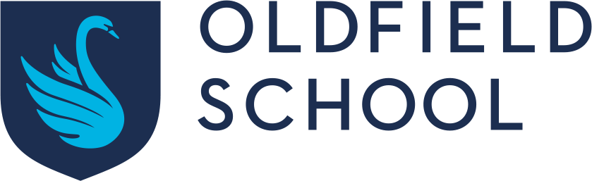

Uniform Grant Form

If your child is eligible for free school meals, we give you a credit note for our school uniform supplier, Price and Buckland, allowing you to purchase up to £85 of uniform over your child’s life at the school. To apply for that credit note, please complete this form.

Parents Name: | Daytime Phone Number:
Student Name: | Intake Year 2022  Year group:
Address:

- We will now verify that your son/daughter is entitled to free school meals.
- Once verified, we will notify Price and Buckland (our uniform provider) who will open a credit account totalling £85 in your name; this will allow you to order whatever items you wish and the school will be invoiced for them.
- The credit account will remain open until you have spent the full £85 or your child leaves the school.
- Once the £85 has been spent, you will not be eligible for any more funds.

Parent/Carer signature: …………………………………………………………….. Date:………………………………………………

Please return the completed form to main reception or by email to: enquiries@oldfieldschool.com by no later than 15th July 2022.

